Part 1: VPC Architecture Design
- Task 1.1
Create Custom VPC
Design and create a VPC with the following specifications:
VPC Name: student-vpc
CIDR Block: 10.0.0.0/16
Enable DNS hostnames: Yes
Enable DNS resolution: Yes
- Task 1.2

Create Subnets
Create the following subnets in different Availability Zones:
- Public Subnet 1: 10.0.1.0/24 (AZ: us-east-1a)
- Public Subnet 2: 10.0.2.0/24 (AZ: us-east-1b)
- Private Subnet 1: 10.0.3.0/24 (AZ: us-east-1a)
- Private Subnet 2: 10.0.4.0/24 (AZ: us-east-1b)

- Task 1.3

Configure Internet Gateway
Create an Internet Gateway named student-igw
Attach it to your VPC
Update route table for public subnets to route 0.0.0.0/0 to IGW
- Task 1.4

Configure NAT Gateway
Create NAT Gateway in Public Subnet 1
Allocate Elastic IP for NAT Gateway
Update private subnet route table to route 0.0.0.0/0 to NAT Gateway
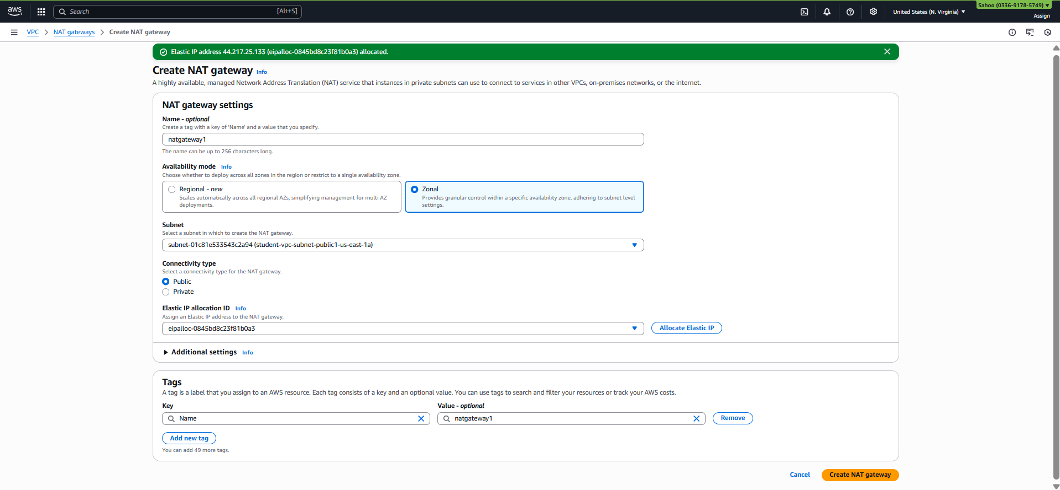
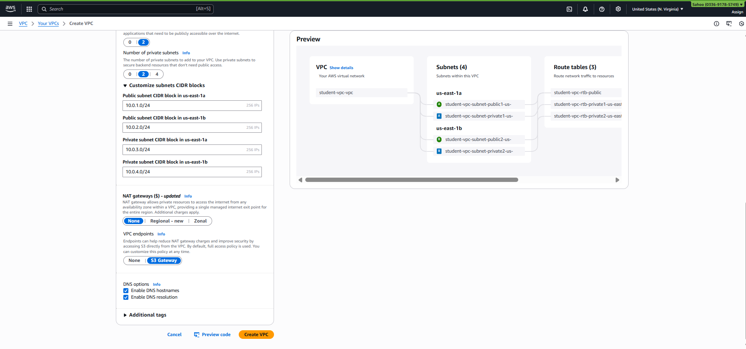
Part 2: Security Configuration
- Task 2.1

Create Security Groups
ALB Security Group (alb-sg):
Inbound Rules:
- HTTP (80) from 0.0.0.0/0
- HTTPS (443) from 0.0.0.0/0
Outbound Rules:
- All traffic to 0.0.0.0/0
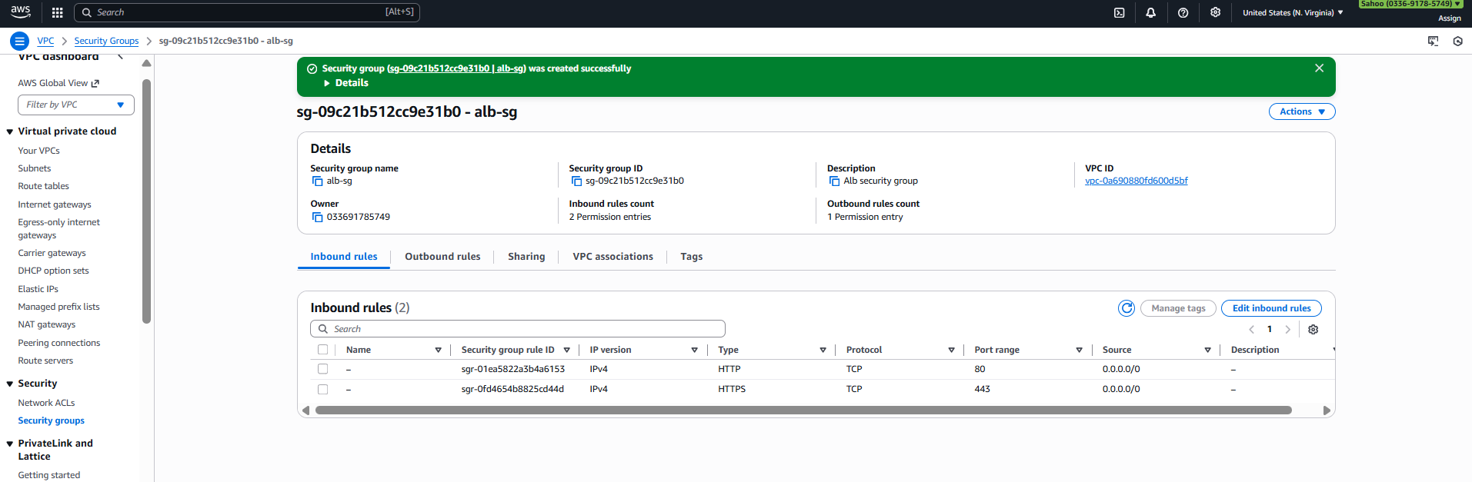

Web Server Security Group (web-sg):
Inbound Rules:
- HTTP (80) from alb-sg
- SSH (22) from your IP
Outbound Rules:
- All traffic to 0.0.0.0/0
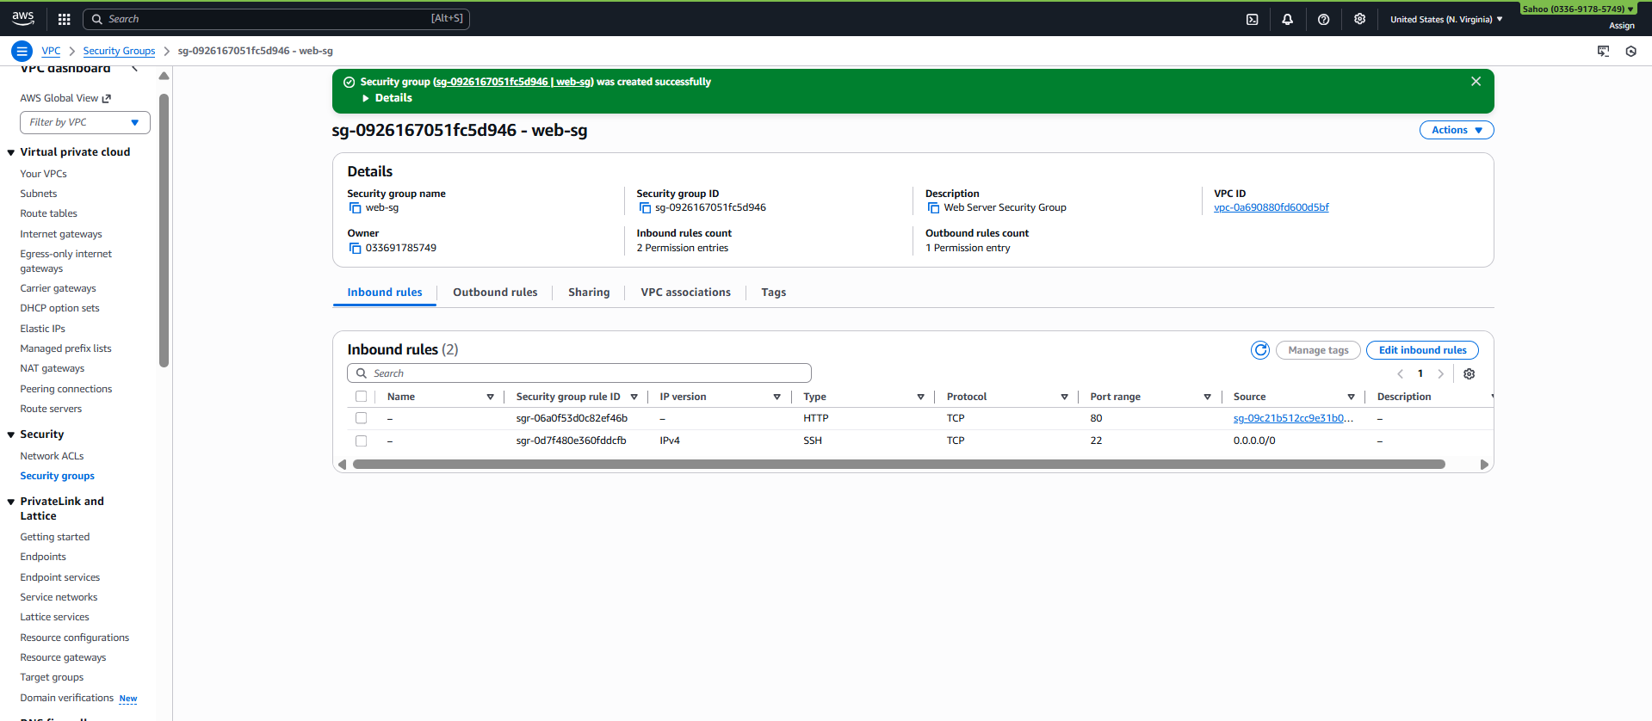

- Task 2.2

Configure Network ACLs
Create custom NACL for public subnets
Allow HTTP/HTTPS inbound and outbound
Allow ephemeral ports (1024-65535)
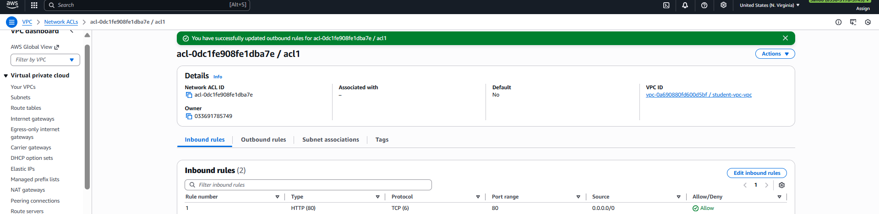
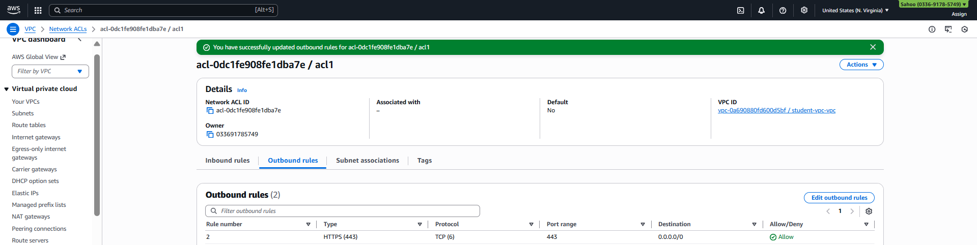
Part 3: Deploy Web Servers
- Task 3.1

Launch EC2 Instances
Launch 2 EC2 instances with the following configuration:
AMI: Amazon Linux 2
Instance Type: t2.micro
Network: student-vpc
Subnet: Private Subnet 1 and Private Subnet 2
Security Group: web-sg
Auto-assign Public IP: Disable
- Task 3.2

Configure Web Server
Use the following User Data script to install Apache web server:
#!/bin/bash
yum update -y
yum install -y httpd
systemctl start httpd
systemctl enable httpd
# Create custom page
INSTANCE_ID=$(curl -s http://169.254.169.254/latest/meta-data/instance-id)
AZ=$(curl -s http://169.254.169.254/latest/meta-data/placement/availability-zone)
cat <<EOF > /var/www/html/index.html
<!DOCTYPE html>
<html>
<head><title>Student Project</title></head>
<body style="font-family: Arial; text-align: center; padding: 50px;">
<h1>VPC & ALB Project</h1>
<h2>Instance ID: $INSTANCE_ID</h2>
<h3>Availability Zone: $AZ</h3>
<p>Student Name: [Your Name]</p>
</body>
</html>
EOF

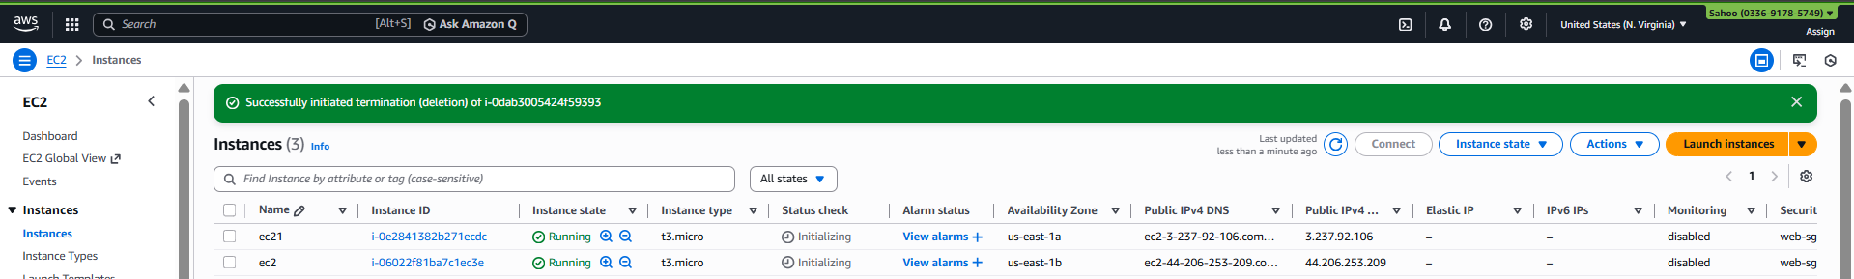
Part 4: Application Load Balancer Setup
- Task 4.1

Create Target Group
Name: student-tg
Target type: Instances
Protocol: HTTP
Port: 80
VPC: student-vpc
Health check path: /
Health check interval: 30 seconds
Healthy threshold: 2
Unhealthy threshold: 2
Register both EC2 instances to this target group.
- Task 4.2

Create Application Load Balancer
Name: student-alb
Scheme: Internet-facing
IP address type: IPv4
VPC: student-vpc
Subnets: Select both public subnets
Security Group: alb-sg
- Task 4.3

Configure Listener

Protocol: HTTP
Port: 80
Default action: Forward to student-tg

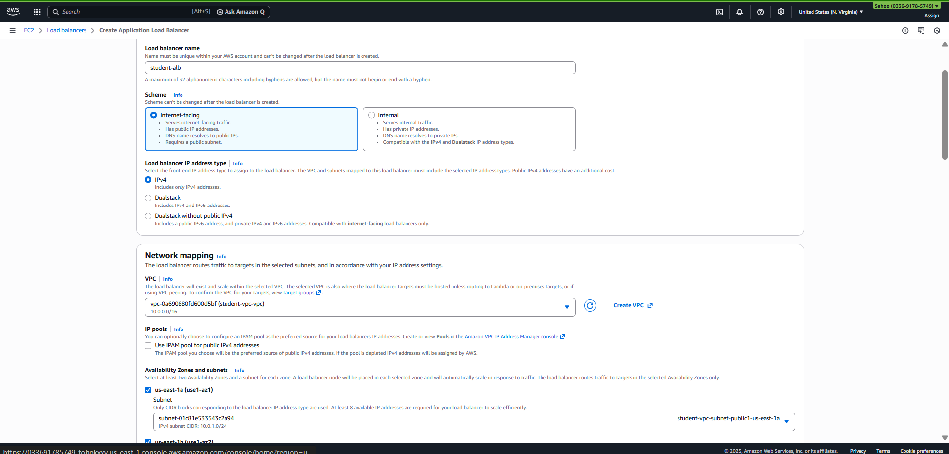
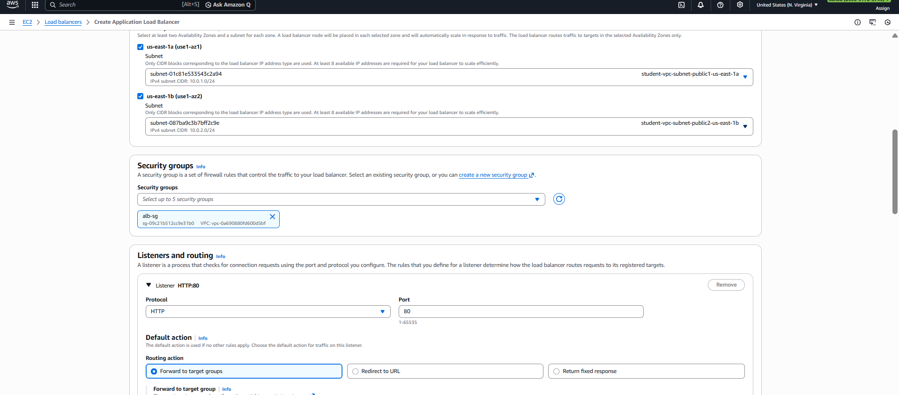
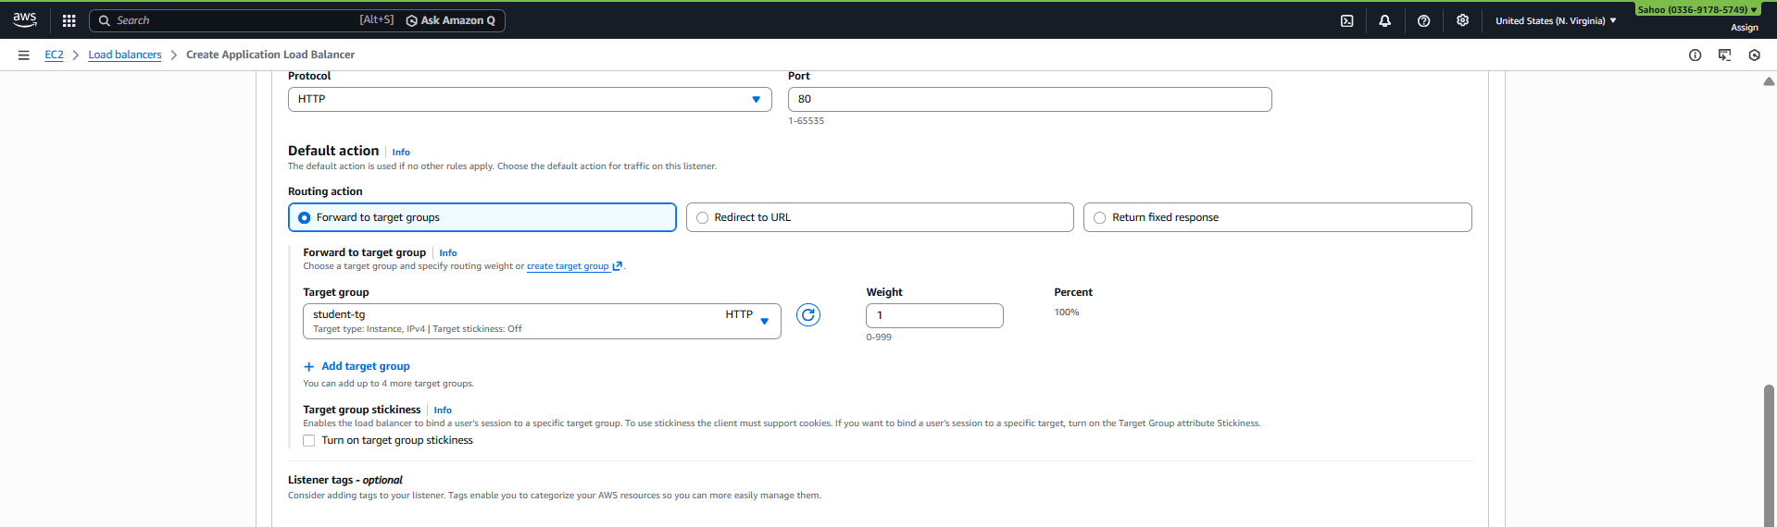

Final output
